TASK 03:
//Tasks 3: You are tasked with developing a program to manage and display the Grade Point Average
//(GPA) for the core courses offered in the first semester of four departments: Software Engineering (SE),
//Artificial Intelligence (AI), Computer Science (CS), and Data Science (DS). Each department offers a
//distinct number of core courses for this semester: SE has 3 core courses, AI has 4 core courses, CS has 2
//core courses, and DS has 1 core course. To efficiently store and present this data, which type of array
//structure would you employ? implement a solution using the chosen array structure to display the GPAs
//of the core courses for each department.

#include<iostream>
using namespace std;

int main()
{
int dept=4;
int **arr=new int *[dept];
int size[4];

for(int i=0;i<dept;i++)
{
cout<<"\nEnter size of dept "<<i+1<<": ";
cin>>size[i];

arr[i]=new int[size[i]];
}

for(int i=0;i<dept;i++)
{
cout<<"\nEnter gpa of "<< size[i] <<" core courses for dept "<<i+1<<": ";
for(int j=0;j<size[i];j++)
{
cout<<"\nCore Course "<<j+1<<" : ";
cin>>arr[i][j];
}
}

cout<<"\n\nThe entered data is : ";
for(int i=0;i<dept;i++)
{
cout<<"\nDept "<<i+1<<": ";

for(int j=0;j<size[i];j++)
{
cout<<arr[i][j]<<" ";
}

cout<<endl;
}

for(int i=0;i<dept;i++)
{
delete[] arr[i];
}

delete[] arr;

return 0;
}

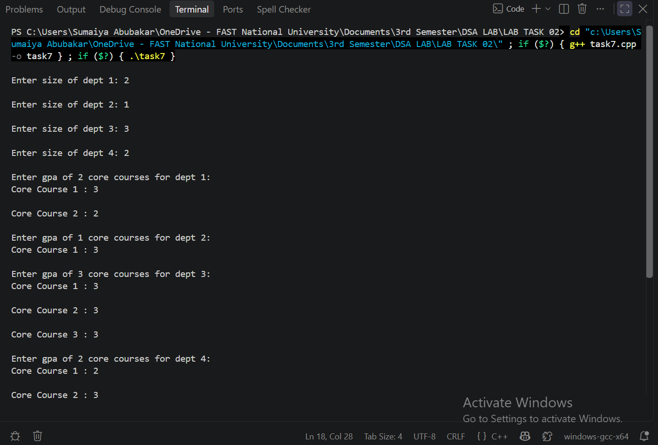
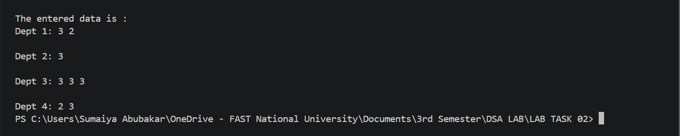

TASK 04:
#include<iostream>
using namespace std;

int main()
{
int rows;

cout<<"Enter number of rows: ";
cin>>rows;

string** seatingChart=new string*[rows];

int* seatsPerRow=new int[rows];

for(int i=0;i<rows;i++)
{
cout<<"\nEnter number of seats in row "<<i+1<<" : ";
cin>>seatsPerRow[i];

seatingChart[i]=new string[seatsPerRow[i]];
cin.ignore();
for(int j=0;j<seatsPerRow[i];j++)
{
cout<<"\nEnter name for seat "<<j+1<<" : ";
// cin>>seatingChart[i][j];

getline(cin,seatingChart[i][j]);
}
}

cout<<"\n\nDISPLAYING SEATING CHART\n\n";

for(int i=0;i<rows;i++)
{
cout<<"Row "<<i+1<<" : "<<endl;

for(int j=0;j<seatsPerRow[i];j++)
{
cout<<seatingChart[i][j]<<" ";
}

cout<<endl;
}

for(int i=0;i<rows;i++)
{
delete[] seatingChart[i];
}

delete[] seatingChart;
delete[] seatsPerRow;

seatingChart=NULL;
seatsPerRow=NULL;

return 0;
}

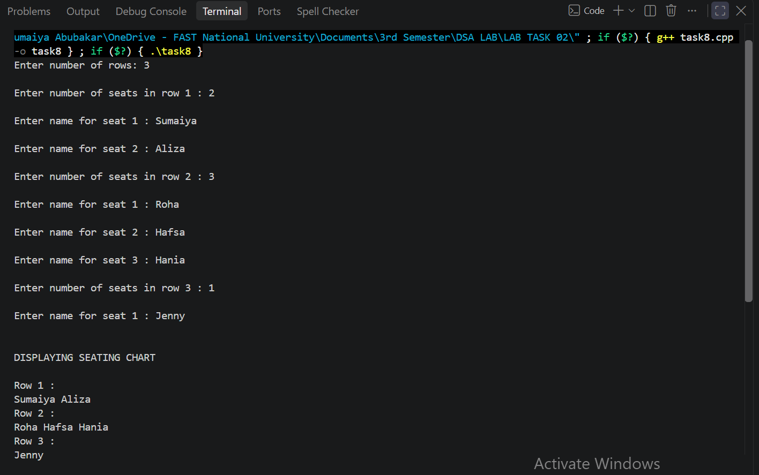

TASK 05:
#include<iostream>
using namespace std;

int main()
{
int rows;

cout<<"Enter number of rows: ";
cin>>rows;

int** elements=new int*[rows];

int* elementsPerRow=new int[rows];

for(int i=0;i<rows;i++)
{
cout<<"\nEnter number of elements of row "<<i+1<<" : ";
cin>>elementsPerRow[i];

elements[i]=new int[elementsPerRow[i]];

for(int j=0;j<elementsPerRow[i];j++)
{
cout<<"\nElement "<<j+1<<" : ";
cin>>elements[i][j];
}
}
int maxElements=0;
int maxRow=0;
for(int i=0;i<rows;i++)
{
if(elementsPerRow[i]>maxElements)
{
maxElements=elementsPerRow[i];
maxRow=i;
}
}
cout << "\nThe row with maximum elements is row " << maxRow + 1 << endl;
cout << "Size of that row: " << maxElements << endl;

cout << "Elements of that row: ";

for(int j=0; j<elementsPerRow[maxRow]; j++)
{
cout << elements[maxRow][j] << " ";
}

for(int i=0; i<rows; i++)
{
delete[] elements[i];
}

delete[] elements;
delete[] elementsPerRow;

elements=NULL;
elementsPerRow=NULL;

return 0;

}

